# 

# Bubble Wrap Abstract Painting

Who isn’t completely captivated by popping the tiny, individual bubbles in bubble wrap?

Regardless of age or ability, bubble wrap is a fun, satisfying way to pass the time. For children with Autism though, bubble wrap can be a sensory adventure. Add to the recipe a little paint? And you’ve got yourself a hybrid between a masterpiece and a playground.

Materials Needed

* Bubble wrap
* Large sheets of paper OR an old bed sheet
* Poster Paints
* Disposable plastic tubs/ or old roller trays
* large area outside (like a driveway or patio) or a covered table
* Sellotape

https://[www.threadedwithlovefromhome.co](http://www.threadedwithlovefromhome.co) <https://www.instagram.com/twlfromhome/>

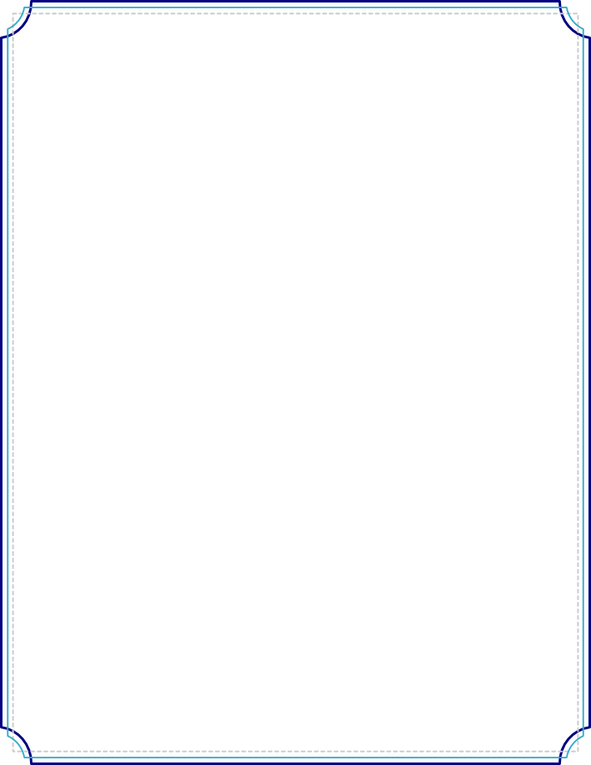Steps

*Step 1.*  
Lay out your large sheet of paper or bed sheet .We recommend laying it down in a non-carpeted area.

*Step 2.*  
Fill your plastic tubs/roller trays with paint and place it/them close to your sheet.

*Step 3.*  
Wrap your kid’s feet in bubble wrap and use the tape to secure their bubble-wrap shoes. (This process should be a good time, even before you start painting!)

*Step 4.*  
Have your child stand in the paint trays.

*Step 5.*  
Let them walk – or dance – or run – or jump on the sheet. Let them paint! Let them enjoy the satisfying sounds of the bubbles popping beneath them!

Alternatively cut some bubble wrap into shapes and allow your child to make shape patterns dipping the shapes into the paint and placing them on the paper/sheet.

Senses Engaged

Sight

Smell

Hearing

✘Taste

Touch

https://[www.threadedwithlovefromhome.co](http://www.threadedwithlovefromhome.co) <https://www.instagram.com/twlfromhome/>